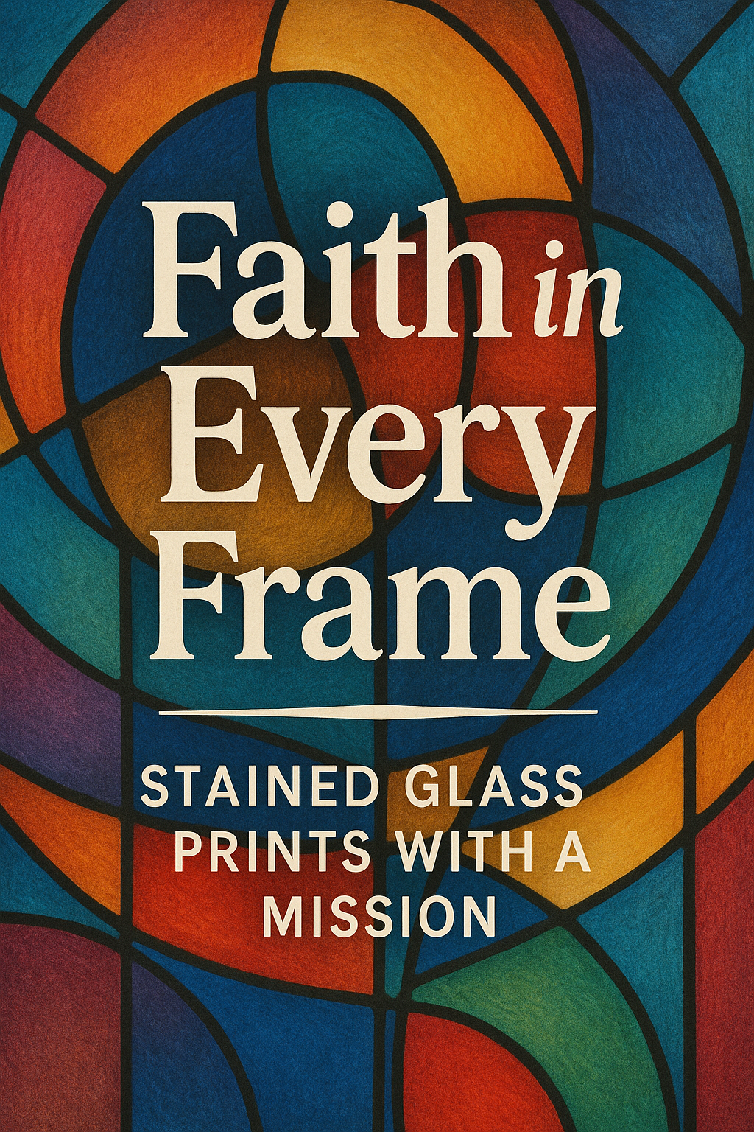
Celebrate the beauty of our Lutheran heritage with professionally printed stained-glass artwork from three LCMS congregations: Trinity Lutheran (Howard’s Grove), Luther Memorial (Sheboygan), and Grace Lutheran (Haven). These prints reflect the rich symbolism and Christ-centered theology found in the stained glass of our sanctuaries.

Available in two framed formats:
• 8.5x11” individual prints at $25.00 per print.
• A 13x19” framed triptych featuring all three
windows together at $45.00 per print.

Each print is professionally produced on Canon Pro Luster paper, a museum-quality photo stock designed for exceptional clarity, deep blacks, and vivid color reproduction.

100% of the proceeds will benefit Meals on Wheels, supporting the physical and spiritual care of our neighbors in need.

Please fill out the order form. Cash or Checks can be left in the envelope provided. Prints will be picked up at church at a later date.

